Manual Review
Prospects: STF shares the information with Backoffice Team via Excel. An email including the same information should follow.

Once the Excel is updated by Backoffice with the the documentation to be requested from customer. The agent will follow up requesting the customer the needed documentation. For that purpose, they will use Tranxfer.

Column T: When a second revision is needed. Further documentation from the customer is needed. In that case, we need to repeat the process and request the documentation specified in that column.

Tranxfer Steps:
- Create an outbound email using the corresponding template
Template: Manual Revision - Template.docx
- Go to Tranxfer and click in Tranxfer Link (right upper corner) > Receive.
This screen will pop up:

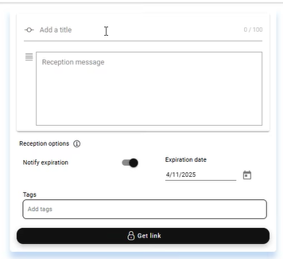

- Add a Title: The CST ID needs to be entered so that the CST receives the reference
- Click on Get a Link (the black button). A link will be generated. Copy the link and adjust the oubound email where the yellow part for the link is. (LINK TRANSFER)

Scenario 1: Customer does not come back with the documentation > Case remains closed. Tranxfer will expire after 15 days. Refence Date is the one in Column P. If CST does not reply after 15 days, please, add CST Did not Reply in Column Q

Scenario 2: Customer comes back with the documentation:
- CST replies with documentation. Please, consider the CST may attach directly the documentation in the email, instead of using Tranxfer. In both cases, same process applies (from Step 2):
- Tranxfer will send a notification to the GDPR Mailbox.
- Agent download the documentation and upload it to the Folder Manual Revision
- For that purpose, a folder needs to be created with the name CST+CST Name. Ex. 123345 – Max Muster
- Update the Column Q in the Excel file including: Documentation received + Data.

